ISYS1055/3412 (Practical) Database Concepts
Assessment 4: Database Design Project
Name: Syeda Shabnam Khan
ID: 4020189

ER Diagram:

Assumptions:
A country can have more than one data sources, therefore, more than one url.
The date repeats for multiple table. This could be made into a table in itself to avoid repeatation. However, this can lead to multiple cyclic relationship. There may be also situations where we don’t have data for a particular date in one of the table. In this case the values will be null for that date.
Since total vaccinations can be calculated from people vaccinated, people fully vaccinated and total boosters, it was removed from the tabe. Same goes for total vaccinations per hundred.
There are some over lapping data in vaccinations and peopleVaccinatedByCountry table. However, the number of rows for a country does not always match. For example the number of observations in the original vaccinations table was not the same as that of the Australia table. Therefore, the columns are repeated.
The multiplicity of state table is (1..N). A country must have atleast one state. For this table we are not considering countries that do not have state. If the we input data from countries without state, the stateName must still have a value. This is because, multiple countries may have states with the same state name. The stateName must be part of the key, therefore cannot be NULL. A work around would be giving states an artificial key or looking up for something similar to the ISO number for countries. However, I am trying to avoid the use of artificial keys where possible for this assignment.
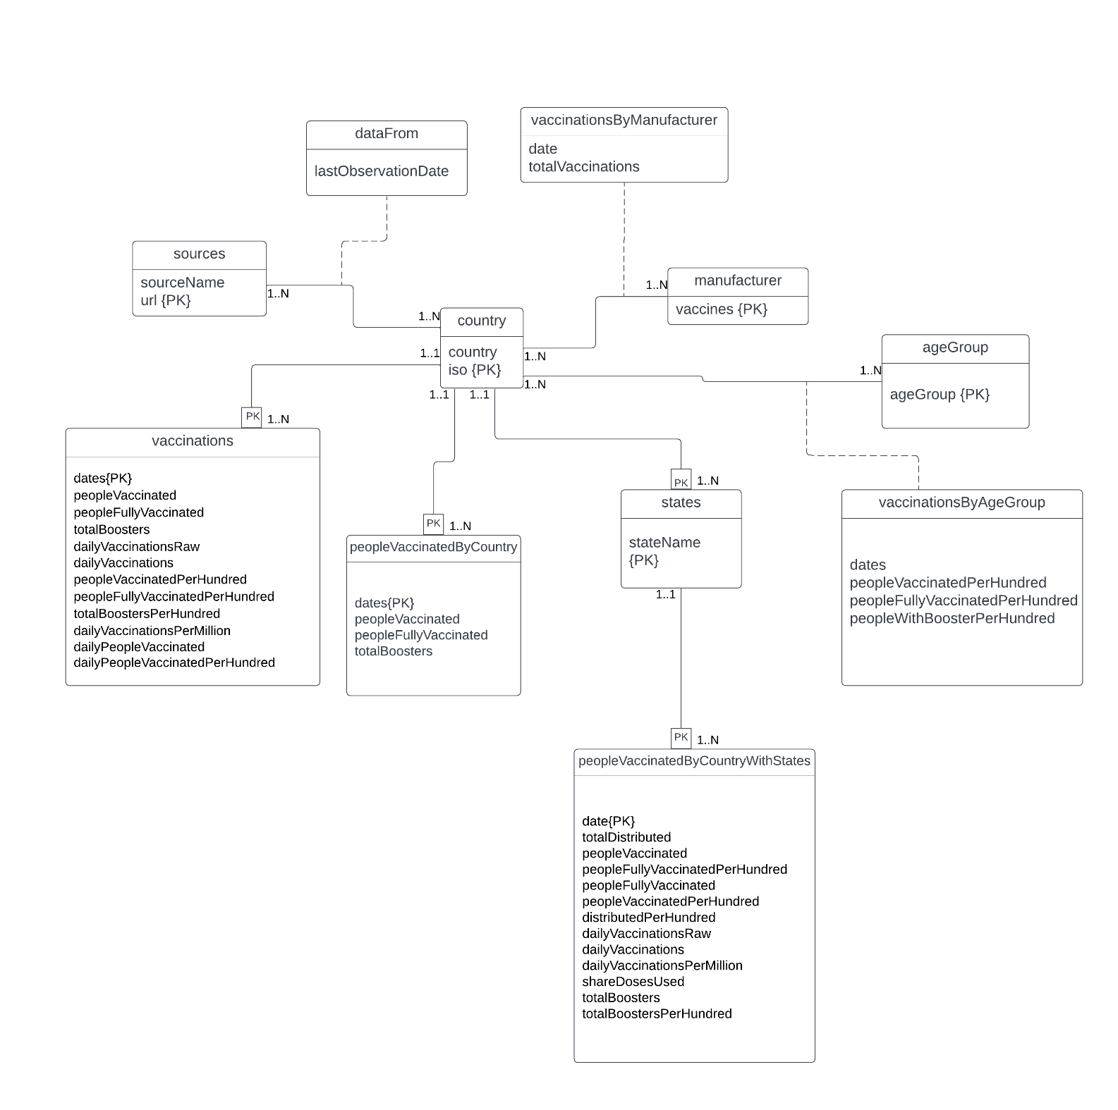

Schema:
country(iso, country)
sources(url, sourceName)
manufacturer(vaccines)
ageGroup(ageGroup)
states(iso*, stateName)
vaccinations(iso*, dates, peopleVaccinated, peopleFullyVaccinated, totalBoosters, dailyVaccinationsRaw, dailyVaccinations, peopleVaccinatedPerHundred, peopleFullyVaccinatedPerHundred, totalBoostersPerHundred, dailyVaccinationsPerMillion, dailyPeopleVaccinated, dailyPeopleVaccinatedPerHundred)
peopleVaccinatedByCountry(iso*, dates, peopleVaccinated, peopleFullyVaccinated, totalBoosters)
peopleVaccinatedByCountryWithStates(iso*, state*, date, totalDistributed, peopleVaccinated, peopleFullyVaccinatedPerHundred, peopleFullyVaccinated, peopleVaccinatedPerHundred, distributedPerHundred, dailyVaccinationsRaw, dailyVaccinations, dailyVaccinationsPerMillion, shareDosesUsed, totalBoosters, totalBoostersPerHundred)
vaccinationsByAgeGroup(iso*, ageGroup*, dates, peopleVaccinatedPerHundred, peopleFullyVaccinatedPerHundred, peopleWithBoosterPerHundred)
vaccinationsByManufacturer(iso*, vaccines*, date, totalVaccinations)
dataFrom(iso*, url*, lastObservationDate)

Functional dependencies:
country:
iso <- country

sources:
url <- sourceName

manufacturer:
The vaccines had no functional dependencies. Therefore, I created a separate table for it.
ageGroup:
ageGroup had no functional dependencies. Therefore, I created a separate table for it.
vaccinations:
iso, dates <- peopleVaccinated, peopleFullyVaccinated, totalBoosters, dailyVaccinationsRaw, dailyVaccinations, peopleVaccinatedPerHundred, peopleFullyVaccinatedPerHundred, totalBoostersPerHundred, dailyVaccinationsPerMillion, dailyPeopleVaccinated, dailyPeopleVaccinatedPerHundred
iso and dates have no functional dependencies, but everything depends on iso and dates together.

peopleVaccinatedByCountry:
iso, dates <- peopleVaccinated, peopleFullyVaccinated, totalBoosters

peopleVaccinatedByCountryWithStates:
iso, state, date <- totalDistributed, peopleVaccinated, peopleFullyVaccinatedPerHundred, peopleFullyVaccinated, peopleVaccinatedPerHundred, distributedPerHundred, dailyVaccinationsRaw, dailyVaccinations, dailyVaccinationsPerMillion, shareDosesUsed, totalBoosters, totalBoostersPerHundred)
Here, I have considered a future scenario where countries other than US will be populated in this table. In that case, multiple countries may have a state with same name. Therefore, state does not have a functional dependency. iso, stateName and date together give everything else.

vaccinationsByAgeGroup:
iso, ageGroup, dates <- peopleVaccinatedPerHundred, peopleFullyVaccinatedPerHundred, peopleWithBoosterPerHundred

dataFrom:
iso, url <- lastObservationDate

states:
Considering more than one country can have the same state name, there is no functional dependency.

The vaccinations table and peopleVaccinatedByCountry table have same primary key. However, as explained before, the rows do not match for some countries. Therefore, they are kept as separate tables.

